Evaluating AI-Assisted Decision Augmentation Systems
Jaxon Doolittle
Georgia Southwestern State University
CSCI 5310: Decision Support Systems
Research Project: Evaluating AI-Assisted Decision Augmentation Systems
Prof. Alexander Yemelyanov
Due: July 28, 2026
Submitted: July 23, 2026

Task 1: ED² Statin Choice – Medical Decision-Making and Reactive Problem-Solving

1. Brief Description of Case 1
Marcus is a hypothetical 48-year-old engineering manager who was just flagged at his annual physical for elevated cholesterol: total cholesterol of 235 mg/dL, LDL-C of 155 mg/dL, HDL-C of 42 mg/dL, and triglycerides of 180 mg/dL, with an untreated systolic blood pressure of 138 mmHg. He has no personal history of cardiovascular disease, but his father had a heart attack at 58, and he's a former smoker who quit five years ago. He carries some real risk factors (overweight, borderline blood pressure, family history) but doesn't fall into a clear-cut category, exactly the kind of gray-zone decision the ACC/AHA guidelines say should involve a clinician-patient discussion rather than a default prescription. Marcus is also a demanding case behaviorally: he's reluctant to be "on a pill for life," has failed at sustained diet and exercise changes twice before, but is highly motivated by his father's heart attack and genuinely worried about his own cardiovascular risk. That mix of real medical risk, and low follow-through confidence is what makes his case a useful test of the app.

2. ED² Statin Choice Application in Both Modes

a) Screenshots
User Profile:
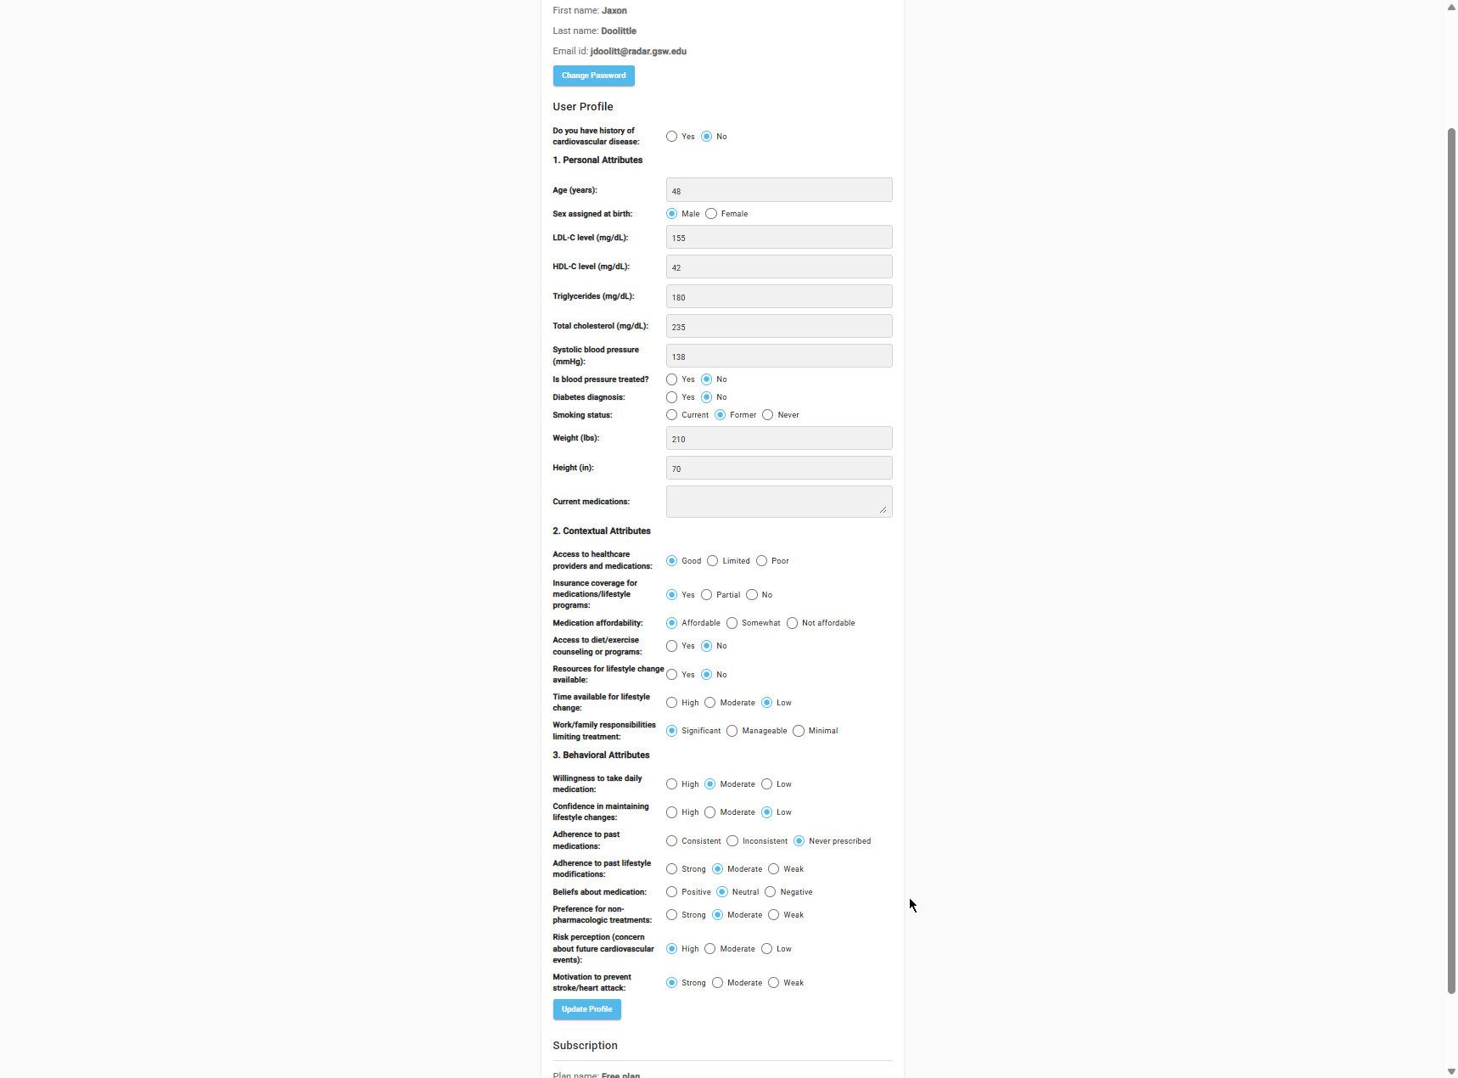
Screenshot 1 — Statin Choice User Profile (Marcus)
Decision-Making Mode – Final Results (all three alternatives):
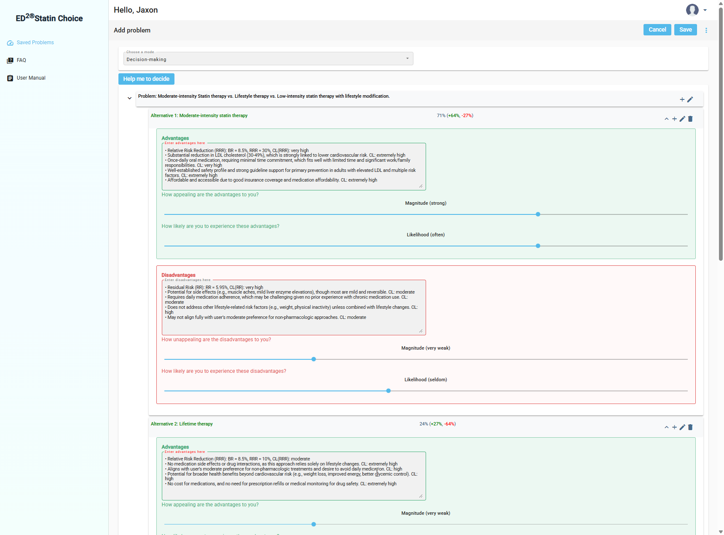
Screenshot 2 — Statin Choice Decision-Making Mode, Alternative 1 rated (71% satisficing)
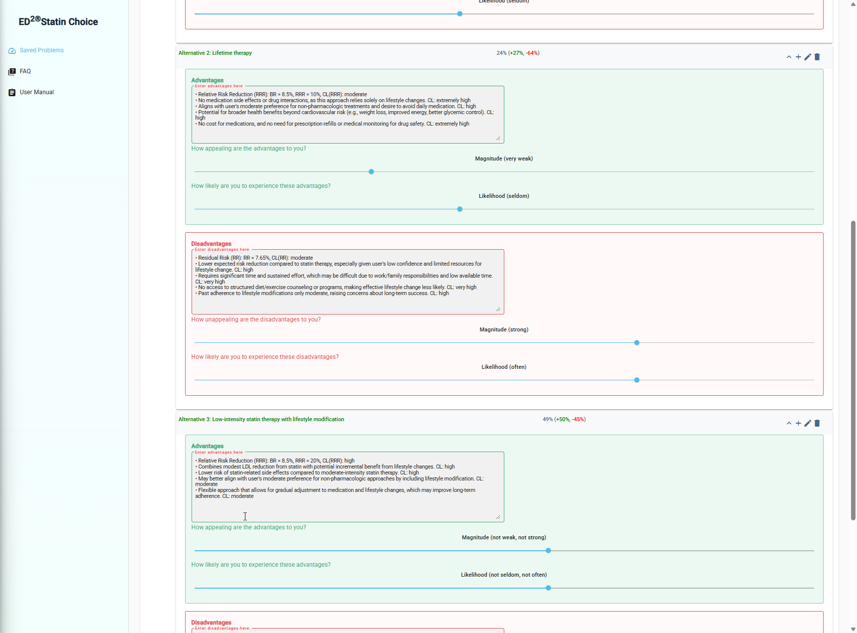
Screenshot 2b — Statin Choice Decision-Making Mode, Alternatives 2 and 3 rated (24% and 49%)
Reactive Problem-Solving Mode – Final Results (all three alternatives):
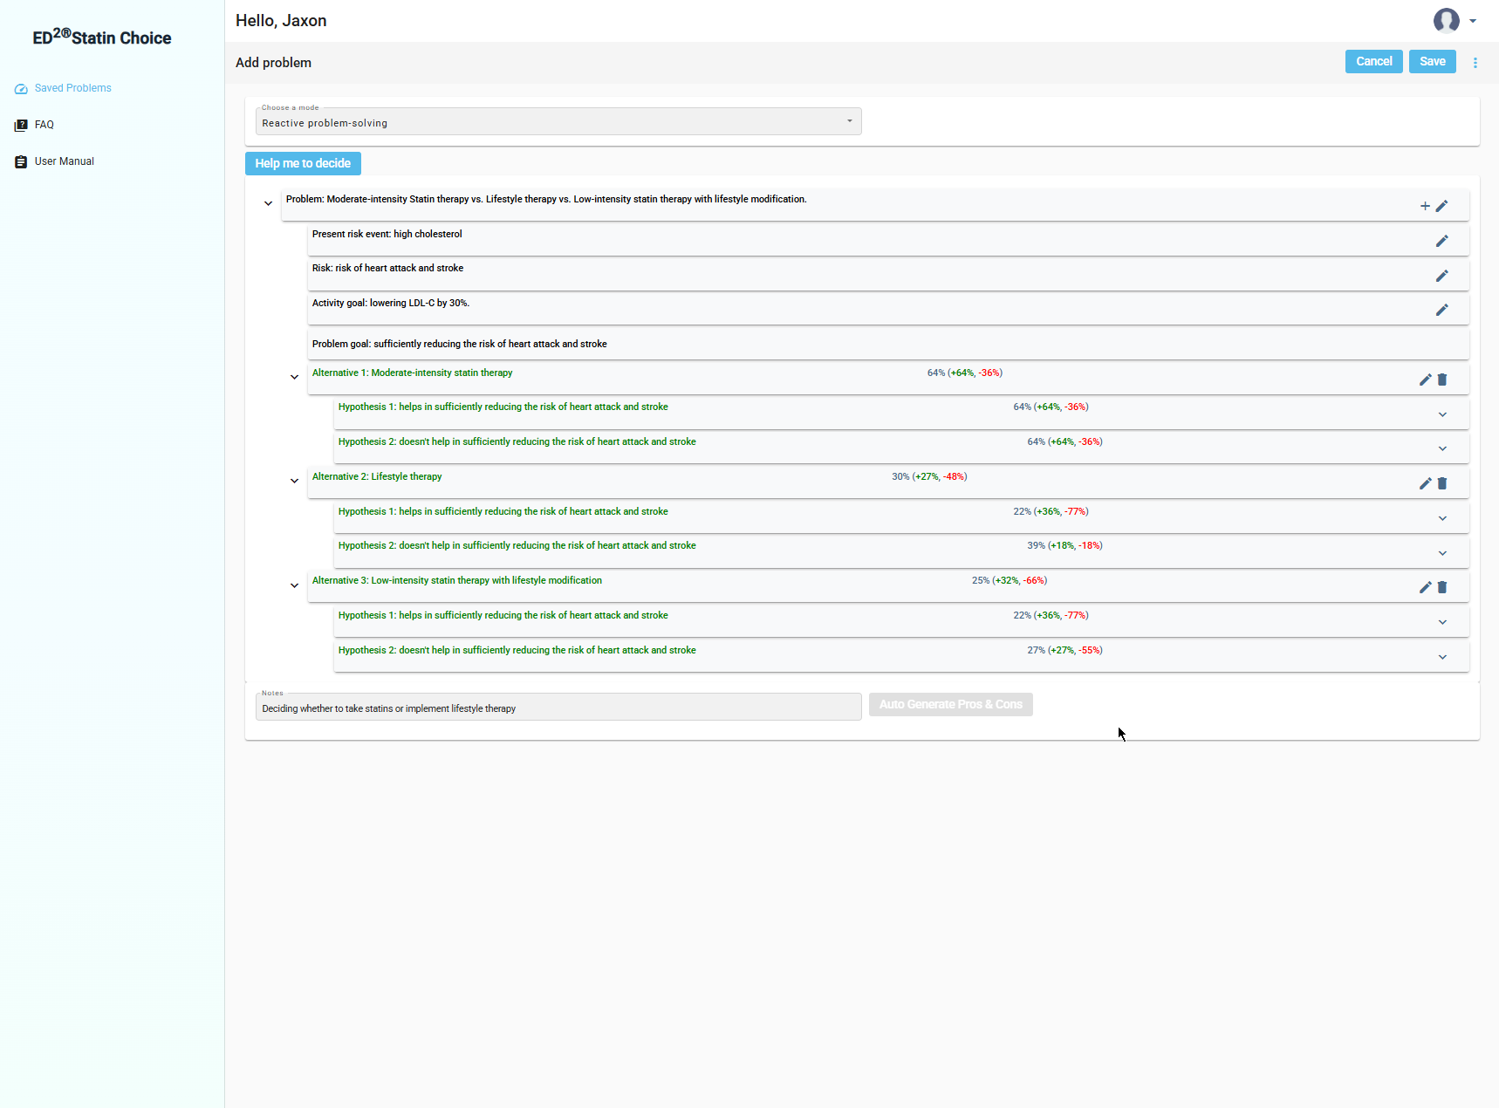
Screenshot 3 — Statin Choice Reactive Problem-Solving Mode, final results (64%, 30%, 25%)

b) Evidence of Self-Efficacy
Coping self-efficacy. While rating the likelihood of the Hypothesis 1 disadvantages (difficulty in lowering LDL-C by 30%) for Alternative 1, moderate-intensity statin therapy, the AI surfaced material, physical, psychological, social, and spiritual challenges, things like unfamiliarity with chronic medication, possible mild side effects, and work/family responsibilities interfering with a daily routine. Even though these are real concerns for Marcus, I rated the magnitude as weak and the likelihood as seldom, because the app's own suggested solutions (setting reminders, integrating the pill into an existing routine like breakfast, working with his provider on any side effects) are realistic and low effort. That's coping self-efficacy in action: my confidence that Marcus can manage the difficulty directly lowered how likely I judged it to actually derail him.
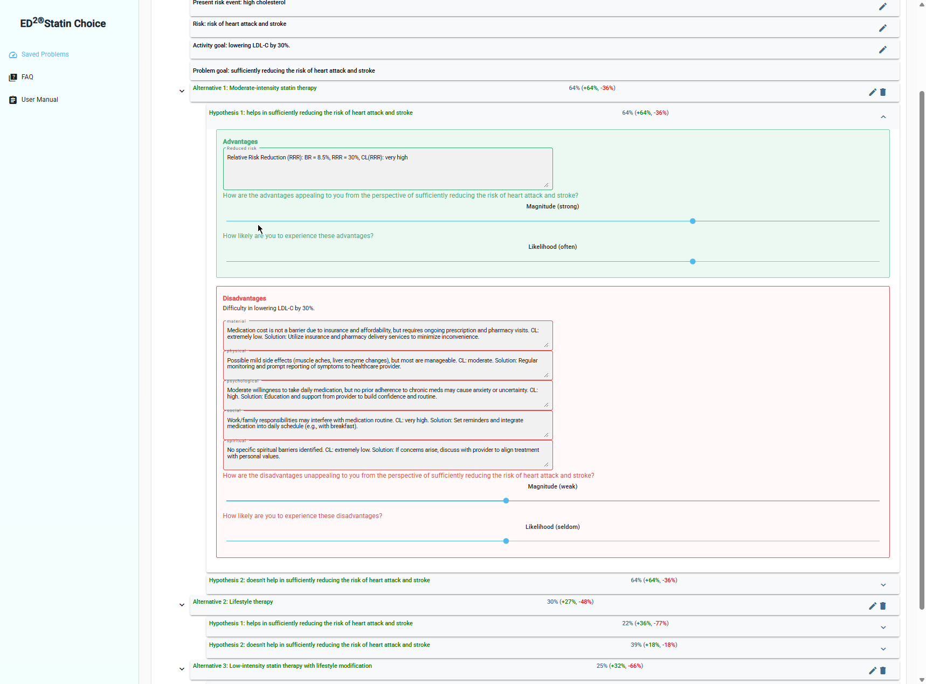
Screenshot 4 — Coping Self-Efficacy: rating likelihood of difficulty (weak / seldom)
Self-regulatory efficacy. While rating the likelihood of the Hypothesis 2 advantages (the significance of successfully lowering LDL-C by 30%) for the same alternative, the AI generated strong physical and psychological benefits, substantially reduced cardiovascular risk and reduced anxiety about future events. I rated the magnitude as strong and the likelihood as often, reflecting my confidence that Marcus, given his high stated concern about his father's heart attack and strong motivation to prevent his own, would actually follow through consistently enough to realize those benefits. That's self-regulatory efficacy: belief in Marcus's ability to sustain the goal-directed effort raised how likely I judged the benefits to occur.
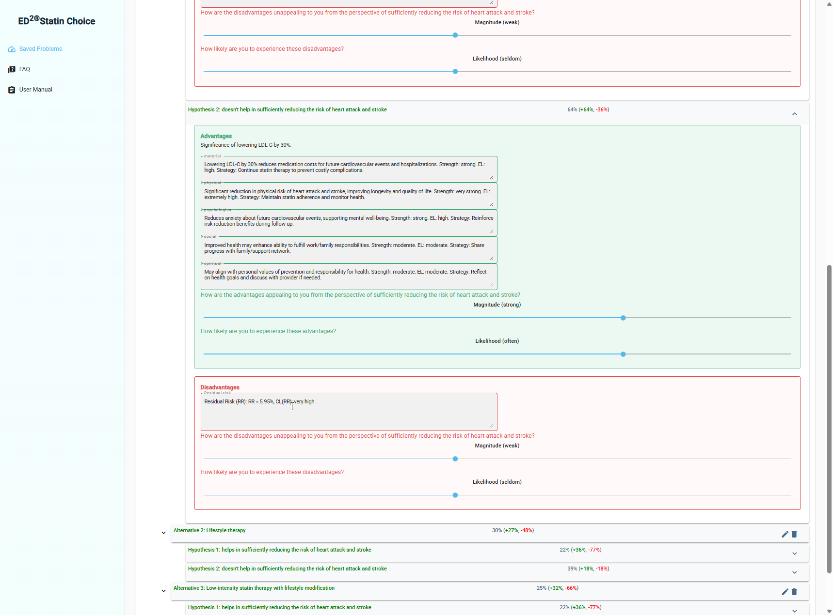
Screenshot 5 — Self-Regulatory Efficacy: rating likelihood of significance (strong / often)
Table 1 summarizes the final satisficing levels across both modes.
Alternative | Decision-Making Mode | Reactive Problem-Solving Mode
Alt 1: Moderate-intensity statin therapy | 71% (+64%, –27%) | 64% (+64%, –36%)
Alt 2: Lifestyle therapy | 24% (+27%, –64%) | 30% (+27%, –48%)
Alt 3: Low-intensity statin + lifestyle modification | 49% (+50%, –45%) | 25% (+32%, –66%)

3. Discussion Questions

a) Consistency among BR, RRR, RR, and Confidence Levels; any inconsistencies or hallucinations?
The Baseline Risk stayed locked at 8.5% across all three alternatives and both modes, which is what you'd expect since BR reflects Marcus's underlying profile, not the alternative being evaluated. The Residual Risk math checked out arithmetically every time: RR = BR × (1 − RRR) gave 5.95% for Alternative 1 (8.5% × 0.70), 7.65% for Alternative 2 (8.5% × 0.90), and 6.8% for Alternative 3 (8.5% × 0.80), all matching the numbers the app displayed. The Confidence Levels also tracked sensibly with the strength of the underlying evidence, CL was "extremely high" on well-established claims like statin safety and guideline support and dropped to "moderate" on softer claims about lifestyle-adherence outcomes.
Where I did notice a real inconsistency was in how much the final satisficing percentages shifted between modes for the same alternative, especially Alternative 3, which dropped from 49% in decision-making mode to 25% in reactive problem-solving mode, a 24-point swing. Both modes still agreed on the overall winner (Alternative 1), and the margin over the runner-up actually got larger in problem-solving mode (34 points vs. 22), so the final recommendation was consistent even though the underlying numbers for the losing alternatives moved around more than I expected. I didn't see anything I'd call an outright hallucination, no numbers that contradicted each other within the same screen, but the app never explains why the same alternative scores so differently once you move from the aggregate advantage/disadvantage view to the hypothesis-based breakdown, which makes it harder to trust that the two modes are really measuring the same thing.

b) Most prominent categories of difficulty and significance; how helpful were the AI-generated solutions?
Psychological and social difficulty were the most prominent categories for Marcus, anxiety about starting a medication he's never taken before, and work/family responsibilities interfering with building a new daily routine. That tracks directly with his profile: low confidence in maintaining lifestyle changes and significant work/family load. On the significance side, physical and psychological significance dominated, meaningfully reduced cardiovascular risk and reduced anxiety about a future heart attack, both of which map straight onto his high concern about repeating his father's history.
The AI-generated solutions were genuinely specific rather than generic. “Set reminders and integrate medication into daily schedule (e.g., with breakfast)” for the social/routine difficulty and “regular monitoring and prompt reporting of symptoms to healthcare provider” for physical side effects both read like something a clinician would actually say, not boilerplate advice. That specificity is what made it reasonable to rate several of the difficulties as low likelihood despite being real concerns on paper.

c) Intuitive choice vs. AI-favored alternative vs. final decision
Going in, my intuitive read of Marcus's case was that he'd lean toward lifestyle therapy, his profile is built around a stated preference for non-pharmacologic treatment and real reluctance about lifelong medication. The app's AI-favored alternative, once actual numbers were on the table, was clearly Alternative 1 (moderate-intensity statin) in both modes, by a wide and consistent margin. My final decision matched the app's recommendation, not my initial intuition.
The reason the two diverged is worth calling out: lifestyle therapy's RRR (10%) was roughly a third of the statin's (30%), and that gap only got more important once I weighed it against Marcus's own documented track record, he'd already failed at sustained lifestyle change twice. Once the evidence-weighted risk reduction and the behavioral profile both pointed in the same direction, my preference-driven intuition (avoid the pill) didn't hold up. That's a fairly direct illustration of what Lehto and Nanda and the DI course materials describe: descriptively, people default to intuitive, preference-driven choices, but a structured decision augmentation process forces a more normative, evidence-weighted evaluation that can override the initial gut call.

d) Extent to which generated outcomes reflected the User Profile
Very closely. The AI explicitly wove specific profile fields into its generated text rather than producing generic statin pros and cons, phrases like “requiring minimal time commitment, which fits well with limited time and significant work/family responsibilities,” “affordable and accessible due to good insurance coverage and medication affordability,” and “may not align fully with user's moderate preference for non-pharmacologic approaches” all tie directly back to specific fields I entered (time availability, insurance coverage, stated treatment preference). That level of specificity is what made the rating process feel meaningful rather than arbitrary.

e) Recommended improvements
The rating sliders apply a single Magnitude/Likelihood pair to an entire block of five advantages or five disadvantages at once, rather than letting the user rate each bullet individually. That's faster to use, but it forces very different concerns, for example, “no cost for medication” and “no side effects” under Lifestyle therapy's advantages, into a single averaged rating, which loses precision exactly where the app is trying to be personalized. Letting users rate difficulty and significance by individual category, the way the reactive mode's hypothesis structure already implies, would make the underlying satisficing math more defensible.
I'd also recommend the app surface an explanation whenever the same alternative's satisficing level shifts significantly between decision-making and problem-solving mode (as Alternative 3 did here, 49% to 25%), so users understand whether that's a meaningful change in the underlying risk model or simply an artifact of the more granular rating structure in reactive mode.

Task 2: ED² Insurance Choice – Reputation Insurance Decision-Making and Proactive Problem-Solving

1. Brief Description of Case 2
For Task 2 I was assigned Reputation insurance. The case is built around a founder profile modeled on my own background running an early-stage AI startup: a public-facing role with press interviews and an active social media presence, an AI product that makes automated decisions for customers, and no dedicated PR or legal staff to absorb a crisis if one hits. The estimated exposure runs $300,000–$500,000 in potential lost revenue, partnerships, and fundraising ability if a reputational crisis occurs disproportionate to the company's size given how quickly a viral complaint or an AI mistake can spread. Financial capacity is moderate: the startup has limited cash reserves and would strain its budget to self-fund a crisis response. Risk tolerance is moderate rather than high, despite general comfort with financial risk from a trading and startup background, because reputational damage is slower to reverse and compounds across investors, customers, and press simultaneously. The decision preference is a balanced approach conscious but not cost-first, and the engagement style is an active researcher who occasionally consults an advisor.

2. ED² Insurance Choice Application in Both Modes

a) Screenshots
User Profile:
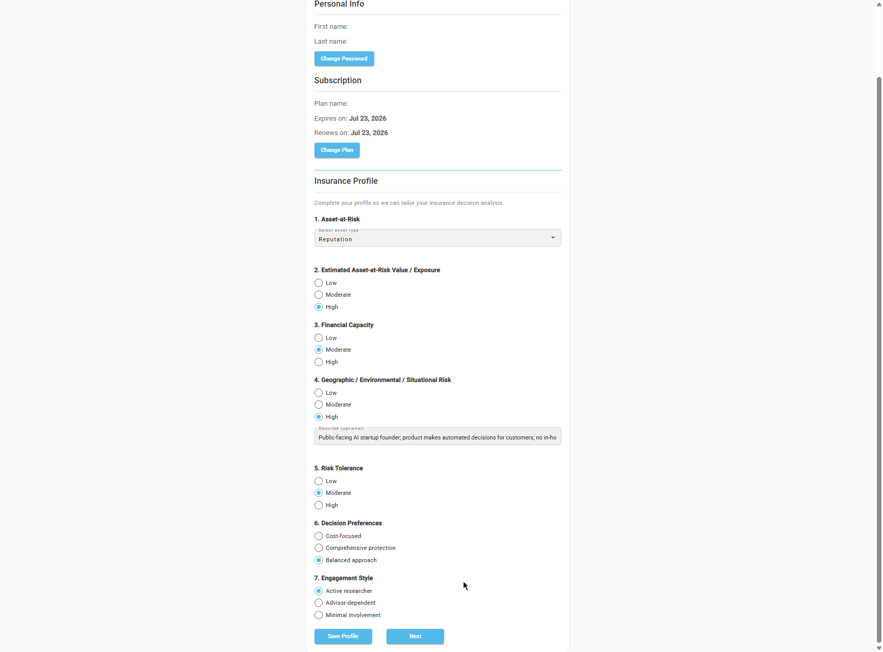
Screenshot 6 — Insurance Choice User Profile (Reputation)
Decision-Making Mode – Final Results (all three coverage alternatives):
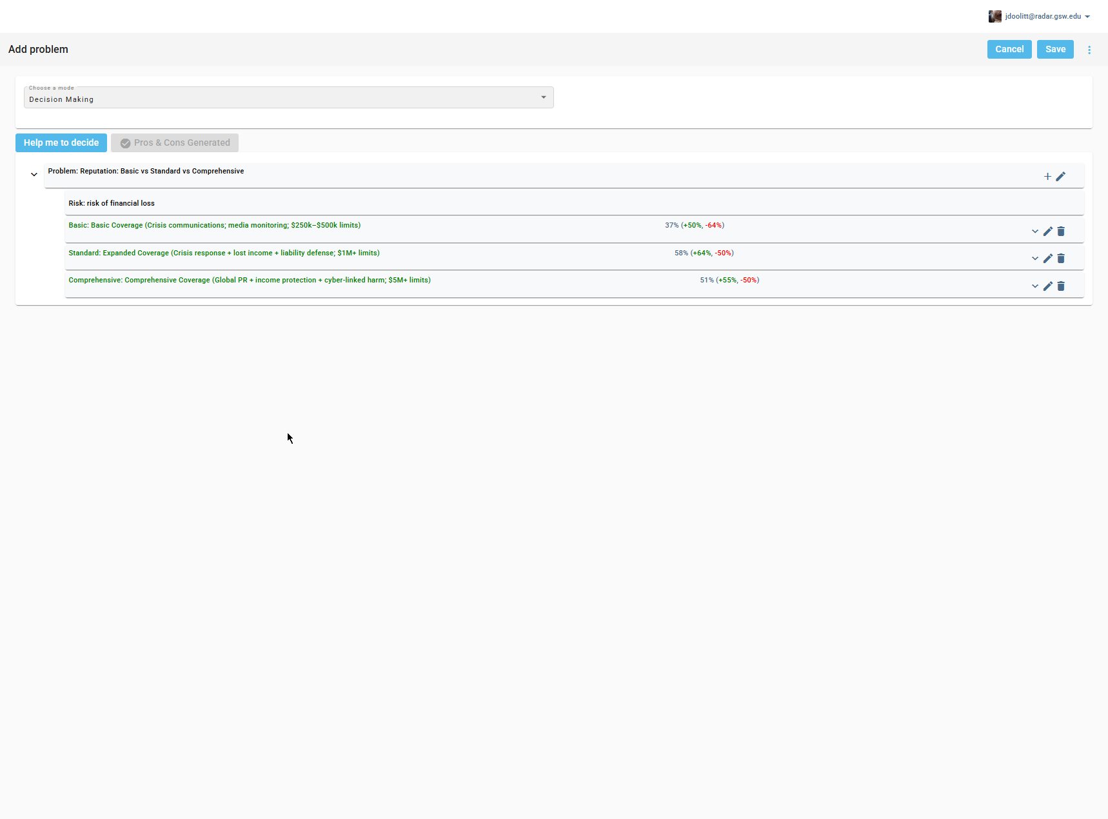
Screenshot 7 — Insurance Choice Decision-Making Mode, final results (37%, 58%, 51%)
Proactive Problem-Solving Mode – Final Results (all three coverage alternatives):
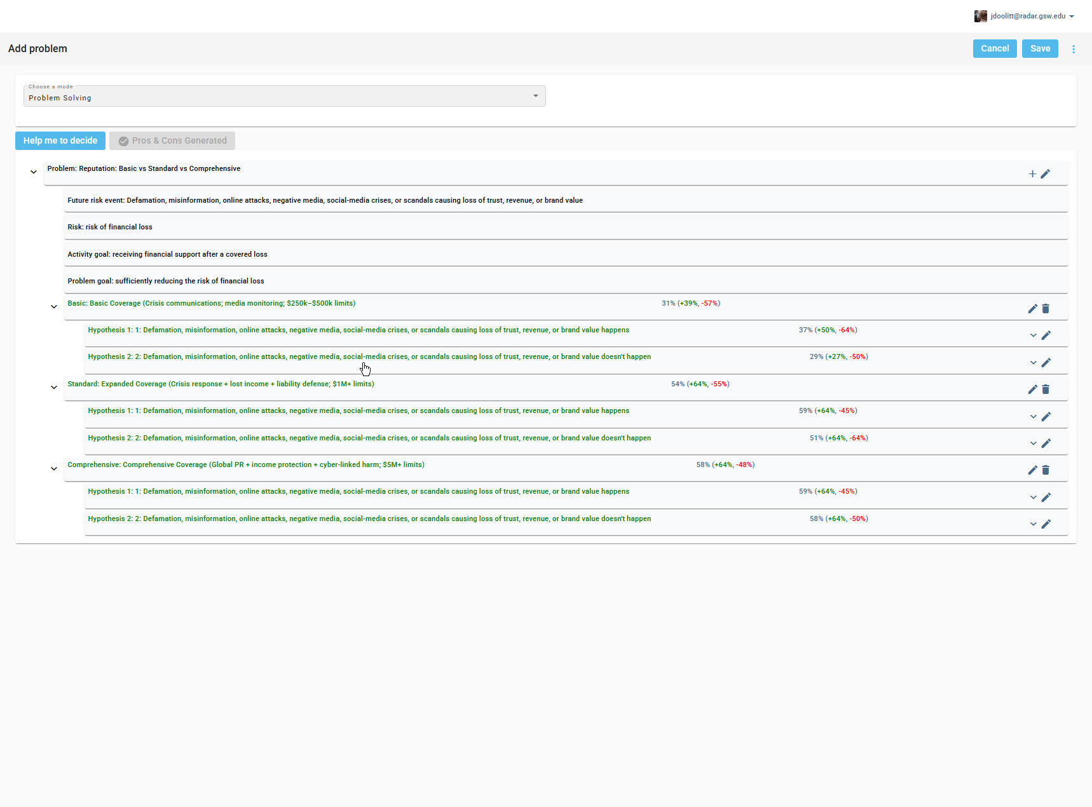
Screenshot 8 — Insurance Choice Proactive Problem-Solving Mode, final results (31%, 54%, 58%)

b) Evidence of Self-Efficacy
Coping self-efficacy. While evaluating the Hypothesis 1 disadvantages (difficulty in receiving financial support after a covered loss) for Basic coverage, the AI flagged material, physical, psychological, social, and spiritual challenges, limited financial coverage not fully addressing high-value reputation risk, stress from managing a crisis with limited support, anxiety over insufficient coverage for major incidents, and strain on professional relationships. Unlike the Statin Choice example, here I rated the magnitude as strong and the likelihood as often, because these difficulties are structural rather than something confidence alone can fix: Basic coverage genuinely does not address the cyber-linked harm and global PR exposure central to an AI startup founder's risk profile, and none of the app's suggested solutions (supplementing with savings, building an advisor network) close that structural gap. That's coping self-efficacy working in the other direction, low confidence that the difficulty can be managed pushed the likelihood rating up, which is part of why Basic coverage's overall satisficing level (31–37%) landed well below the 51% threshold.
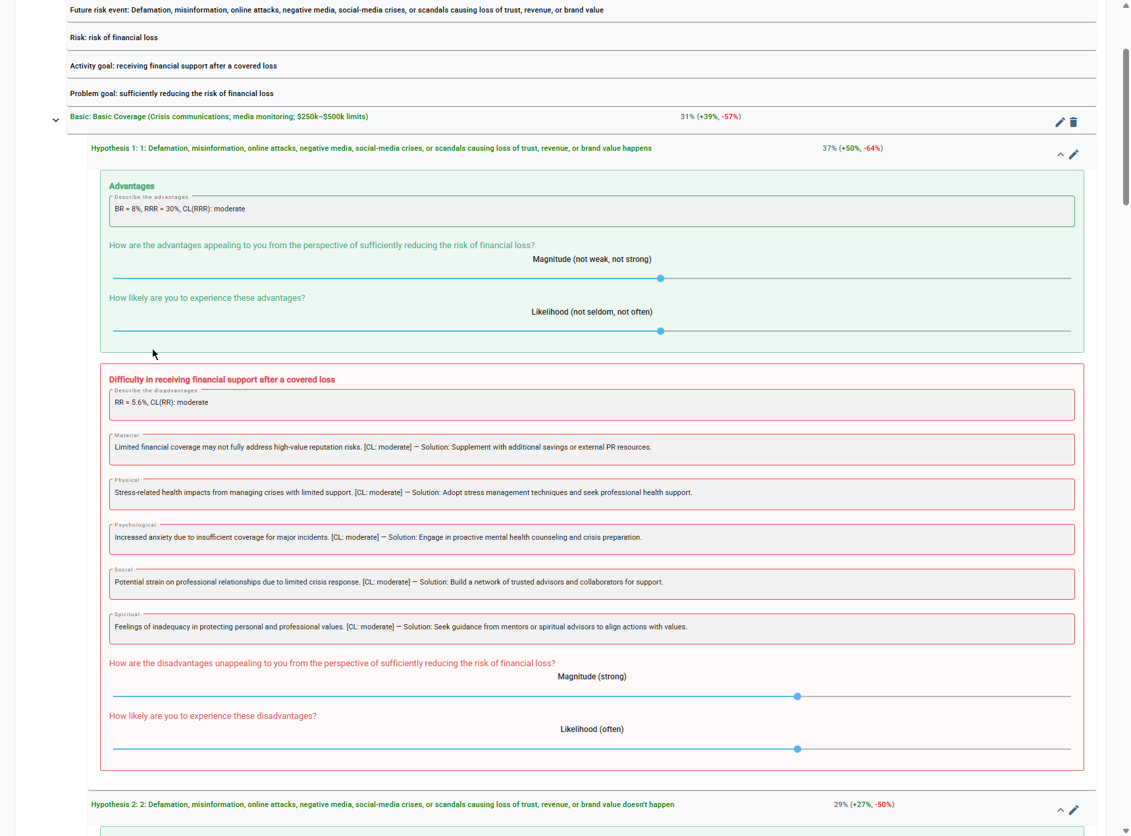
Screenshot 10 — Coping Self-Efficacy: rating likelihood of difficulty (strong / often), Basic coverage

Self-regulatory efficacy. While evaluating the Hypothesis 2 advantages (the significance of receiving financial support while sufficiently reducing risk) for Comprehensive coverage, the AI generated its strongest-worded significance language across every category “maximum financial security,” “highest level of peace of mind,” “enhanced reputation as a highly prepared and responsible professional.” Rating the likelihood of those benefits as often reflects confidence that the founder would actually follow through on maintaining the coverage and leveraging it, communicating preparedness to stakeholders, reflecting on long-term goals, rather than letting the policy sit unused. That's the self-regulatory efficacy component: belief in sustained follow-through raising the likelihood rating for the benefit.
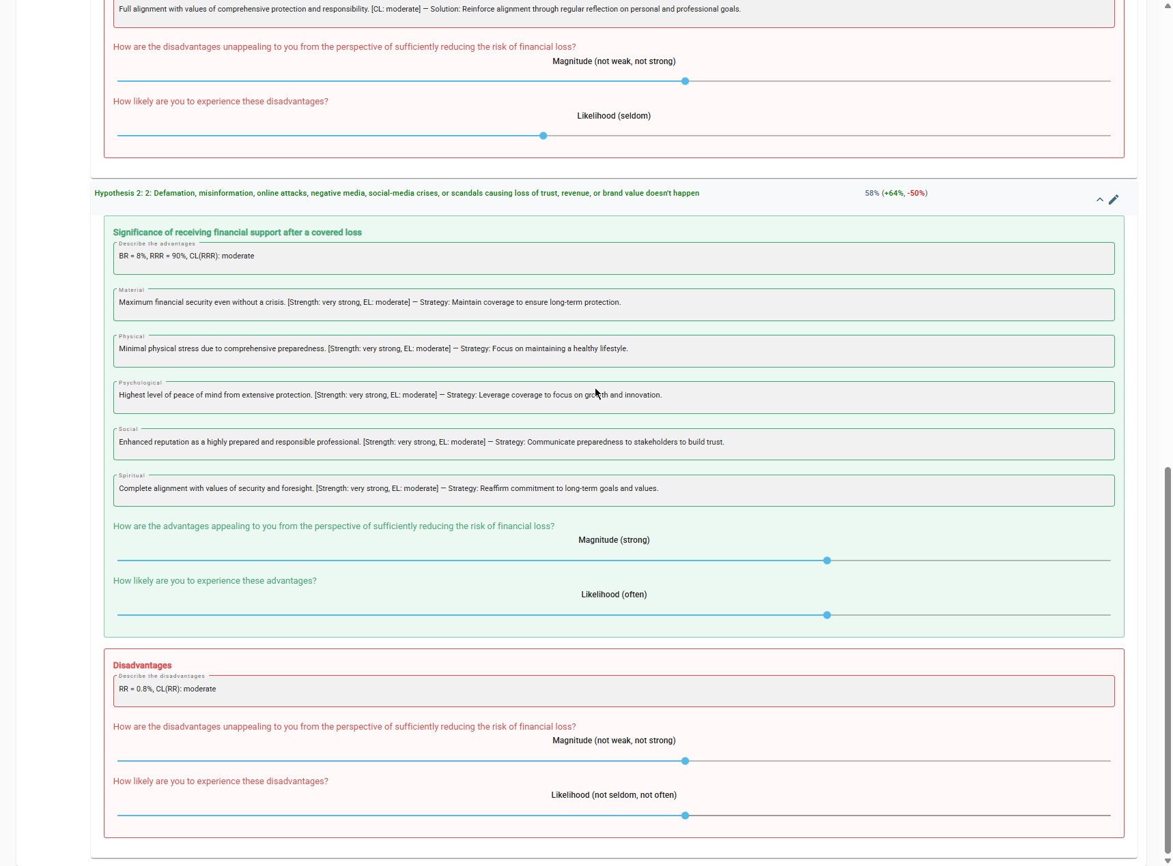
Screenshot 9 — Self-Regulatory Efficacy: rating likelihood of significance (strong / often)
Table 2 summarizes the final satisficing levels across both modes.
Coverage Alternative | Decision-Making Mode | Proactive Problem-Solving Mode
Basic (Crisis comms + media monitoring; $250k–$500k limits) | 37% (+50%, –64%) | 31% (+39%, –57%)
Standard (Expanded coverage; $1M+ limits) | 58% (+64%, –50%) | 54% (+64%, –55%)
Comprehensive (Global PR + cyber-linked harm; $5M+ limits) | 51% (+55%, –50%) | 58% (+64%, –48%)

3. Discussion Questions

a) Consistency among BR, RRR, RR, and Confidence Levels; any inconsistencies or hallucinations?
Baseline Risk held steady at 8% across all three coverage tiers and both modes. The Residual Risk math checked out arithmetically in every case: RR = BR × (1 − RRR) gave 5.6% for Basic (8% × 0.70), 2.4% for Standard (8% × 0.30), and 0.8% for Comprehensive (8% × 0.10), matching the app's displayed figures exactly.
The clearest inconsistency I found was in the Difficulty sections (Hypothesis 1 disadvantages) for Standard and Comprehensive coverage. Several of the auto-generated entries under the Physical, Psychological, Social, and Spiritual categories actually described positive outcomes rather than genuine difficulties, for example, “Enhanced ability to maintain professional relationships during crises,” “Full alignment with values of comprehensive protection and responsibility,” and “Significant peace of mind from extensive coverage,” all listed under Difficulty. Those read like benefits that got mislabeled, not real challenges. It looks like the AI ran short of genuine difficulty content for the higher coverage tiers (where there genuinely is less to complain about) and defaulted to restating advantages under the wrong heading rather than acknowledging that a tier has minimal difficulty. That's a real content-generation inconsistency worth flagging, even though the underlying facts weren't factually wrong.

b) Most prominent categories of difficulty and significance for Reputation insurance; how helpful were the AI-generated solutions?
Material difficulty was the dominant, most legitimate concern across all three tiers. Basic's limited coverage not addressing the real cyber-linked harm and global PR exposure of an AI startup, and Standard/Comprehensive's premium cost straining the profile's stated moderate financial capacity. That tension between what full protection costs and what the profile says is affordable is the central conflict running through this case. Psychological significance, peace of mind and confidence, was the dominant benefit category once meaningful coverage was in place, especially for Comprehensive.
The solutions were reasonable but more generic than I'd like for a case this specific. “Budget for premiums and explore flexible payment options” and “evaluate cost-benefit trade-offs and explore financing options” are sound general advice, but they don't get specific to an early-stage startup's actual financing tools, bundling reputation coverage into a broader D&O or tech E&O policy, or negotiating a premium schedule tied to funding milestones, would have been more useful and more personalized than what the app generated.

c) Intuitive choice vs. AI-favored alternative vs. final decision
My intuitive pick going in was comprehensive, given the startup's real exposure to cyber-linked harm and global PR risk, the highest tier felt like the obviously safe answer. Decision-making mode actually favored Standard (58%) over Comprehensive (51%), a 7-point gap. Problem-solving mode narrowed that gap further, with Comprehensive edging ahead at 58% versus Standard's 54%, a 4-point margin that falls inside the 5% proximity threshold AHFE papers describe for this framework, even though the interface itself never explicitly flagged a proximity alert.
My final decision landed on Standard, not my original intuitive pick of Comprehensive. The deciding factor was the material-difficulty theme both modes kept surfacing: Comprehensive's premium genuinely strains the profile's stated moderate financial capacity, while Standard already closes most of the risk gap (RRR 70% vs. 90%, RR 2.4% vs. 0.8%) and comfortably clears the 51% satisficing threshold on its own. This is a good real-world example of the tension the Insurance Choice paper describes between cognitive risk reduction and motivational/financial constraints, the numerically “safest” option isn't automatically the satisficing one once actual financial capacity gets weighed into the picture.

d) Extent to which generated outcomes reflected the User Profile
Strongly. The generated content repeatedly referenced my exact profile fields by name, “aligning with the user's moderate risk tolerance and balanced decision preferences,” “supporting the user's active engagement style,” “addressing critical risks for the user's AI startup environment,” and “may exceed the user's moderate financial capacity.” The Geographic/Situational Risk description I typed into the profile, public-facing AI founder, no in-house PR or legal team, showed up nearly verbatim in some of the generated advantage and disadvantage text for Comprehensive coverage. That's a tight enough match to confirm the profile fields are directly driving the underlying prompt, not just cosmetically referenced somewhere in the output.

e) Recommended improvements
First, fix the Difficulty/Significance mislabeling identified in 3a the app should either generate genuinely negative content for every coverage tier's Difficulty section or explicitly state when a tier has minimal difficulty, rather than restating advantages under the wrong heading. Second, the proximity between Standard and Comprehensive (4–7 points across both modes) never triggered a visible proximity alert, even though it fell well within the threshold the app's own underlying framework describes. Surfacing that alert explicitly and prompting the user toward the “refine your decision” step described in the manual adding a new objective to sharpen the Problem Goal would make the tool's stated methodology more visible and would have helped resolve the Standard-vs-Comprehensive tension more systematically instead of leaving it to my own judgment call.

